Making Room: Inside Museum of City of New York’s ‘Launch Pad’ Model Micro Apartment
September 6, 2013 12:59 PM
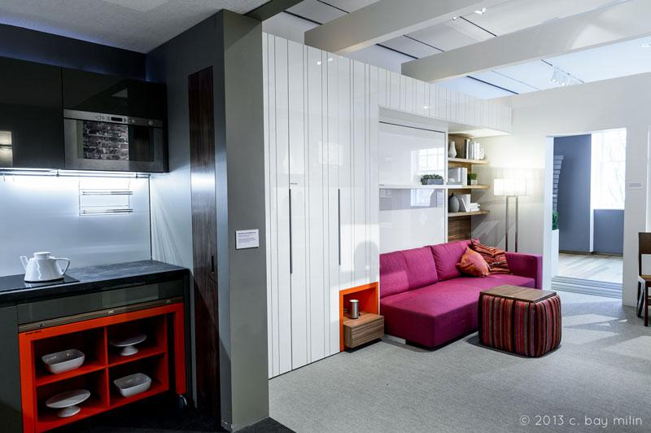

Are even tinier apartments the answer to better accommodating the emerging housing needs of major cities? An exhibition at the Museum of City of New York suggests as much, and the “live smarter and smaller” theme seems to be resonating—the popular show on new housing models has been extended to September 15. We asked writer Nancy Lazarus to head over to the museum’s fully built “micro unit” and make herself at home.
---------------------------------------------------------------
About thirty curious visitors filed into a 325-square-foot full-scale studio apartment model on a recent Friday afternoon. The occasion wasn’t a real estate open house, but a chance to experience a highly touted micro-unit called “The Launch Pad.”
The furnished model (pictured above) serves as the centerpiece of “Making Room: New Models for Housing New Yorkers,” an exhibition on view through September 15 at the Museum of the City of New York. Amie Gross Architects and interior designer Pierluigi Colombo, founder of Resource Furniture, collaborated on the unit’s design.
Architectural models and design solutions from New York and selected cities worldwide are also showcased. These coincide with New York Mayor Michael Bloomberg’s initiative to offer more affordable, though smaller-scale, housing options for the growing ranks of single city residents.
An open ambience prevailed inside the micro-unit, not claustrophobia, as skeptical attendees may have expected. They soon learned key elements for optimizing space from Jeffrey Phillip, an organizing pro who specializes in blending style and efficiency.
“We all struggle with living in small spaces, but small spaces are also grand spaces,” Phillip said. He showed visuals to illustrate the advice he offers to space-challenged clients. While a few concepts were conventional, others were counterintuitive. Some mini spaces benefit more from design makeovers.
Ceiling height matters a lot, and the micro-unit model featured nine-foot ceilings. Phillip suggested painting ceilings to elongate the room and using them as storage to open up floor space. Pendant lamps or even bicycles can hang from ceilings, though no items were suspended from the museum unit.
Let there be light, and don’t block its path, Phillip cautioned. Minimal style, low-profile furniture fits the bill, as do mirrors to reflect space, sheer drapes and raised blinds. To create a warmer atmosphere, he prefers multiple light sources, with bigger fixtures to add height and scale. A large standing lamp and track lighting illuminated the micro-unit.
Color accents rule, and “just because you live in a small space, it doesn’t have to be bland,” Phillip observed. He’s in favor of light colors to add reflection, and a darker accent wall to make far walls appear to recede. The micro-unit featured light colors, a gray kitchen area and a bright berry sofa.
Accessorizing wisely not only lends personality to petite spaces but avoids clutter and distractions, Phillip noted. Overall, he prefers fewer but larger high quality pieces. That applies to artwork, which needs matching frames. To pull the room together he likes sizable rugs with either big patterns or none at all. The micro-unit had a plain recyclable vinyl beige rug.
Double-duty furniture serving multiple purposes is essential, Phillip said. The micro-unit featured a number of transformable pieces: the Murphy bed folded out over the sofa, the TV slid aside to reveal a mini-bar, a chair turned into a stepladder. Hidden storage is key, and the ottoman stored four stools.
Common areas represent an additional way to make life easier for the space-deprived, as shown in another part of MCNY’s exhibit. In 2012 the city launched ADapt NYC, a design competition to develop micro units on Manhattan’s East 27th Street. The winning “MyMicroNY” plan calls for a garden, a multi-purpose ground floor with a café, lounge, and space for creative performances. Scores of curious residents are likely to show up for tours of those models.
Nancy Lazarus’s is a frequent contributor to UnBeige

